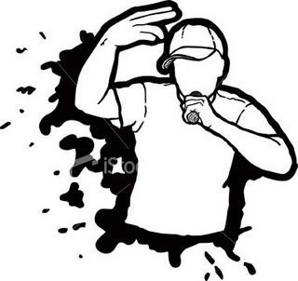

LITERATURE

**RAPPERS IMAGES UNWRAPPED!**

FILM

EYA

PLAYS